The Heart And Vessels
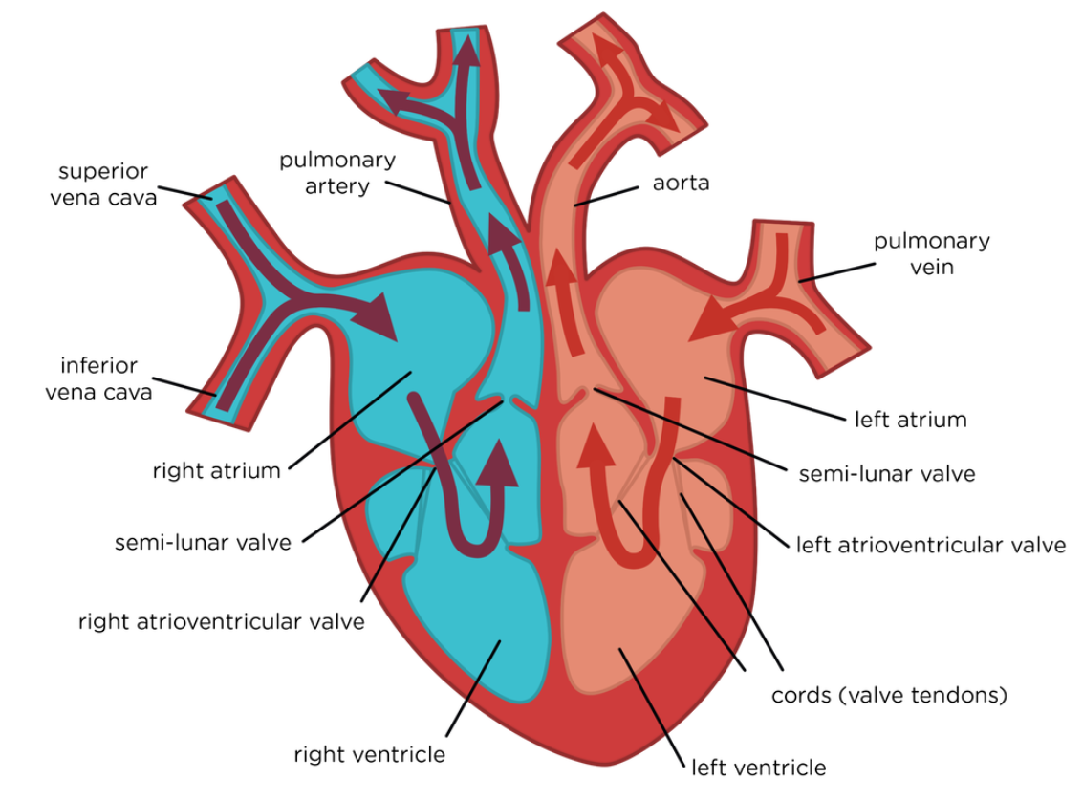
Atrial Systole:
- Atria contract
- A-V valves pushed open by pressure
- Blood pushed to ventricles
- S-L valves closed to stop backflow
Ventricular Systole
- A-V valves close to stop backflow – no pressure to open them
- Ventricles contract
- S-L valves open by pressure
- Blood pushed through Arteries
Cardiac Diastole:
- Atria relaxed and filling
- A-V valves partially open, so ventricles relaxed partially filling
- S-L valves closed to stop backflow

